1.AVERAGE AGE FORMALE AND FEMALE

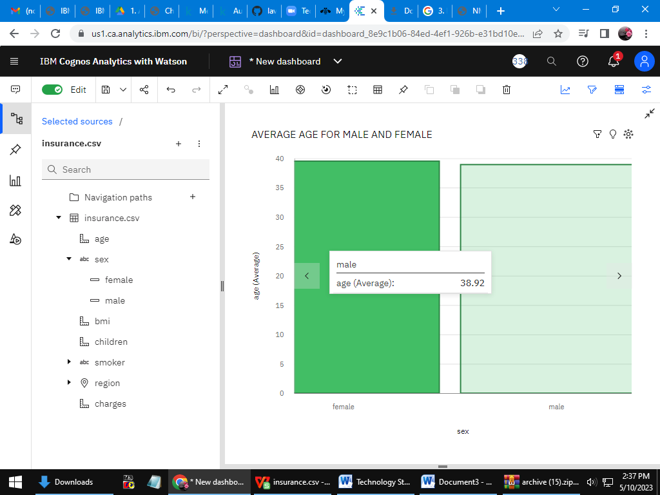

LINK:action=view&mode=dashboard&subView=model000001880514b0c6\_00000000https://us1.ca.analytics.ibm.com/bi/?perspective=dashboard&pathRef=.my\_folders%2Fdatavisuliation&

2. Bmi of a person by age

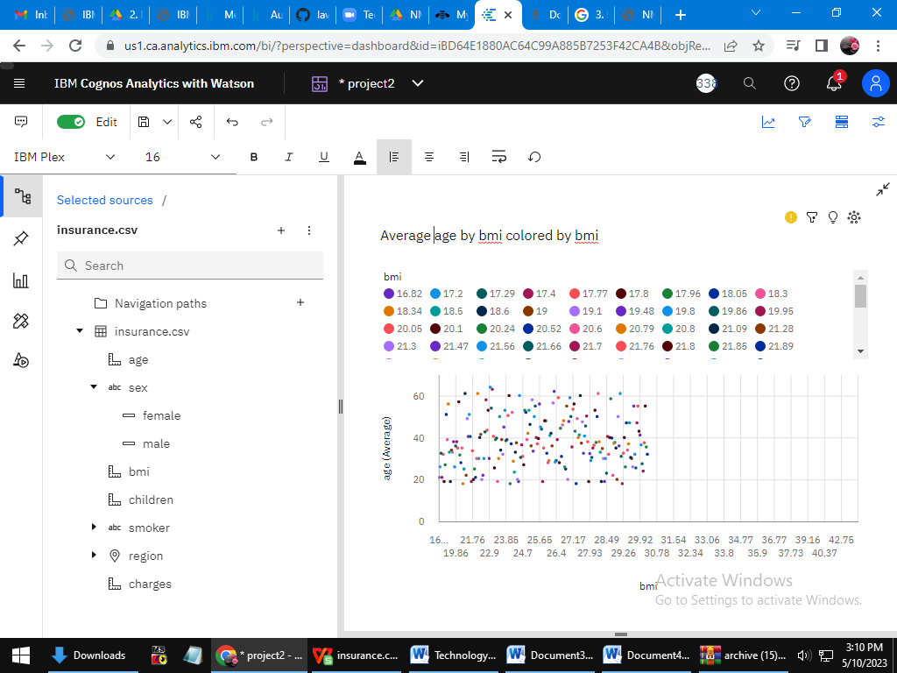

Link:<https://us1.ca.analytics.ibm.com/bi/?perspective=dashboard&pathRef=.my_folders%2Fdatavisuliation&action=view&mode=dashboard&subView=model000001880514b0c6_00000000>

3.  Number of children by age and smoker

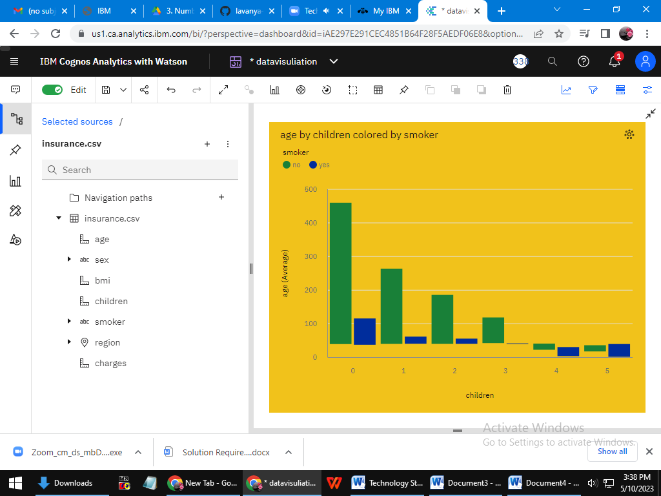

LINK:<https://us1.ca.analytics.ibm.com/bi/?perspective=dashboard&pathRef=.my_folders%2Fdatavisuliation&action=view&mode=dashboard&subView=model000001880514b0c6_00000000>

4.The Average age of people according to this region and gender

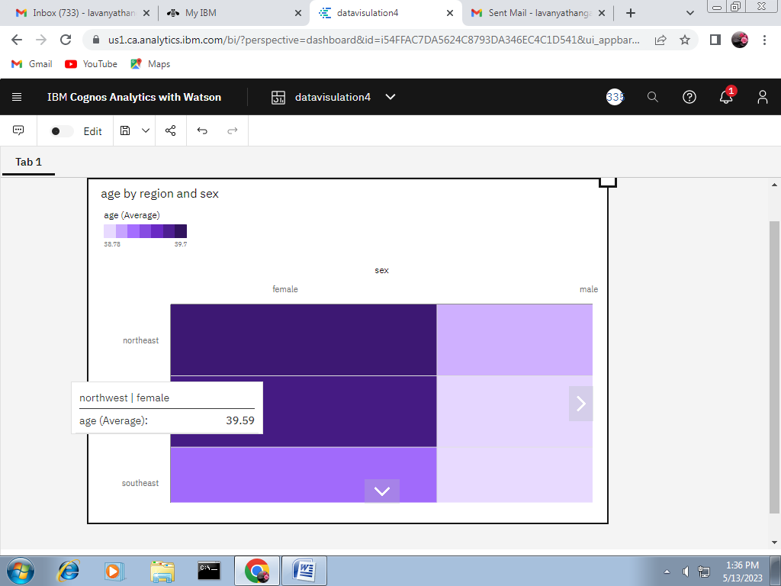

Link: <https://us1.ca.analytics.ibm.com/bi/?perspective=dashboard&pathRef=.my_folders%2Fdatavisulation4&action=view&mode=dashboard&subView=model00000188141febb6_00000000>

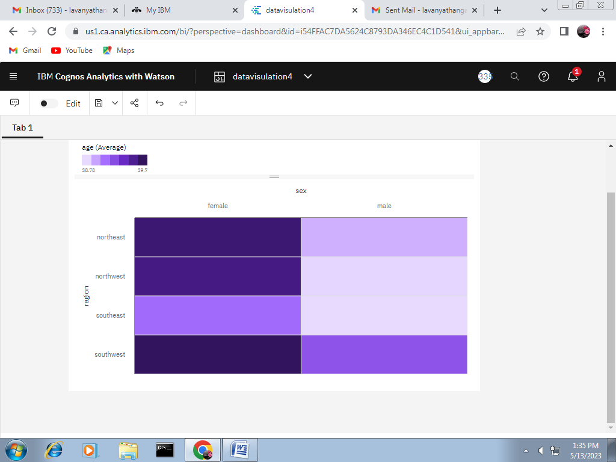

5.charge paid by people according to their age smoker

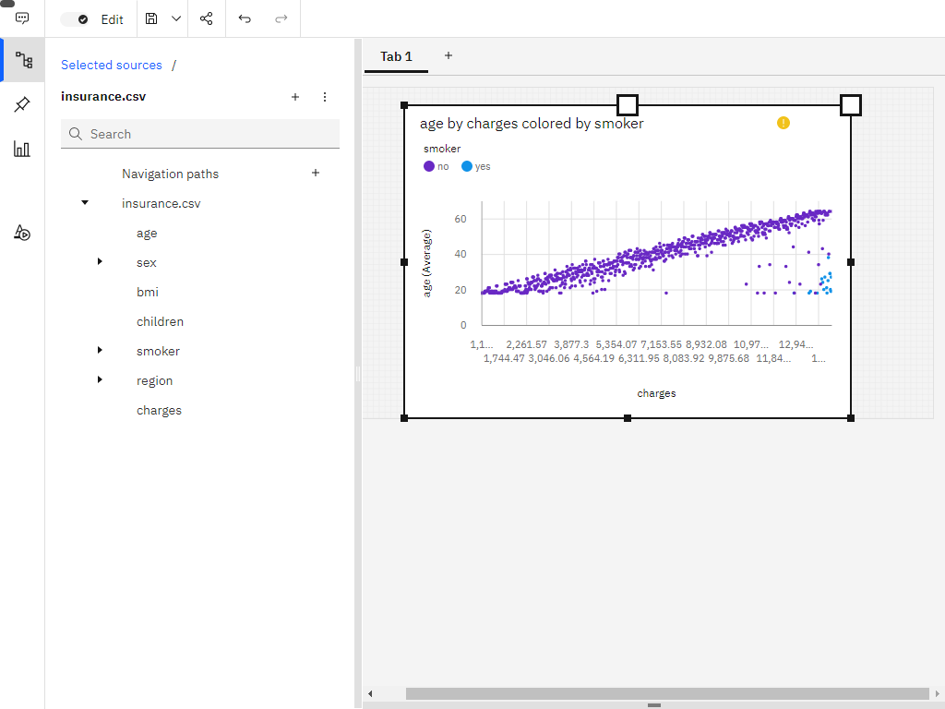

Link: <https://us1.ca.analytics.ibm.com/bi/?perspective=dashboard&pathRef=.my_folders%2Fdatavisulation5&action=view&mode=dashboard&subView=model000001881428d727_00000002>

6.  BMI of a person by their gender and smoker

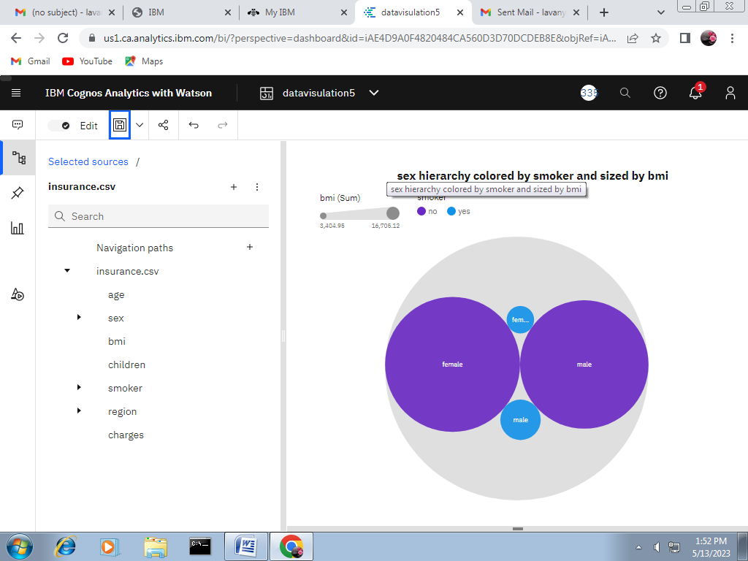

Link: <https://us1.ca.analytics.ibm.com/bi/?perspective=dashboard&pathRef=.my_folders%2Fdatavisulation5&action=view&mode=dashboard&subView=model000001881428d727_00000002>

7. Charges paid by people according to their gender, region and smoker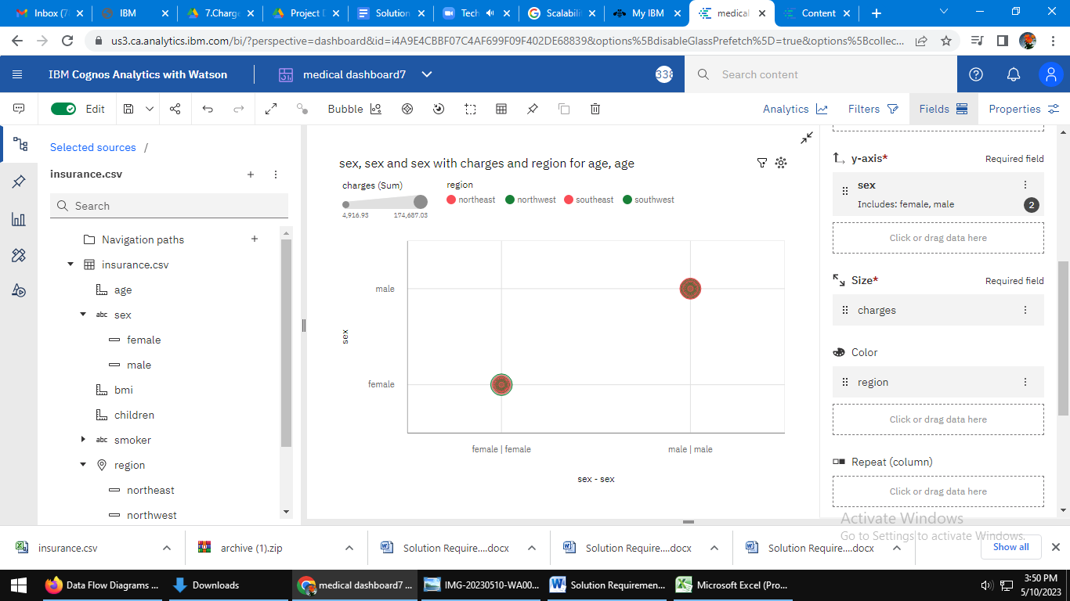

link:<https://us3.ca.analytics.ibm.com/bi/?perspective=dashboard&pathRef=.my_folders%2Fmedical%2Bdashboard7&action=view&mode=dashboard&subView=model000001880514c28f_00000000>

8.  Average BMI of people by gender and region

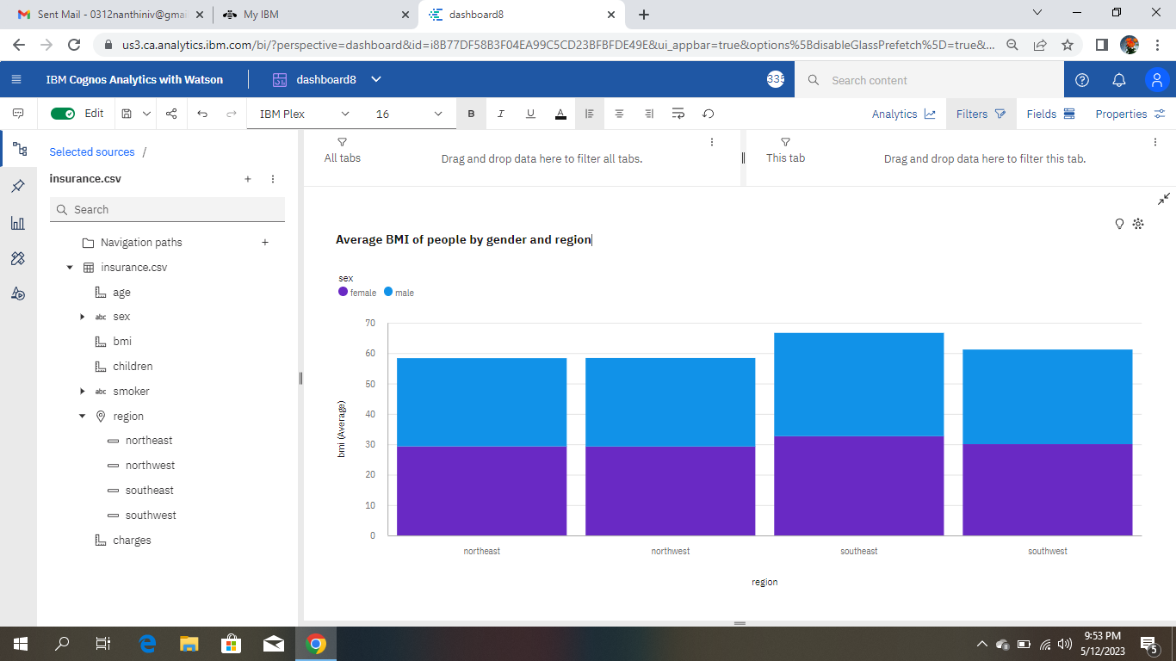

Link:[https://us3.ca.analytics.ibm.com/bi/?perspective=dashboard&pathRef=.my\_folders%2Fdashboard8&action=view&mode=dashboard&subView=model0000018814708b61\_00000000](https://us3.ca.analytics.ibm.com/bi/?perspective=dashboard&pathRef=.my_folders%2Fdashboard8&action=view&mode=dashboard&subView=model0000018814708b61_00000000" \t "_blank)

9. Top 100 charges paid by people based on BMI and coloured by region

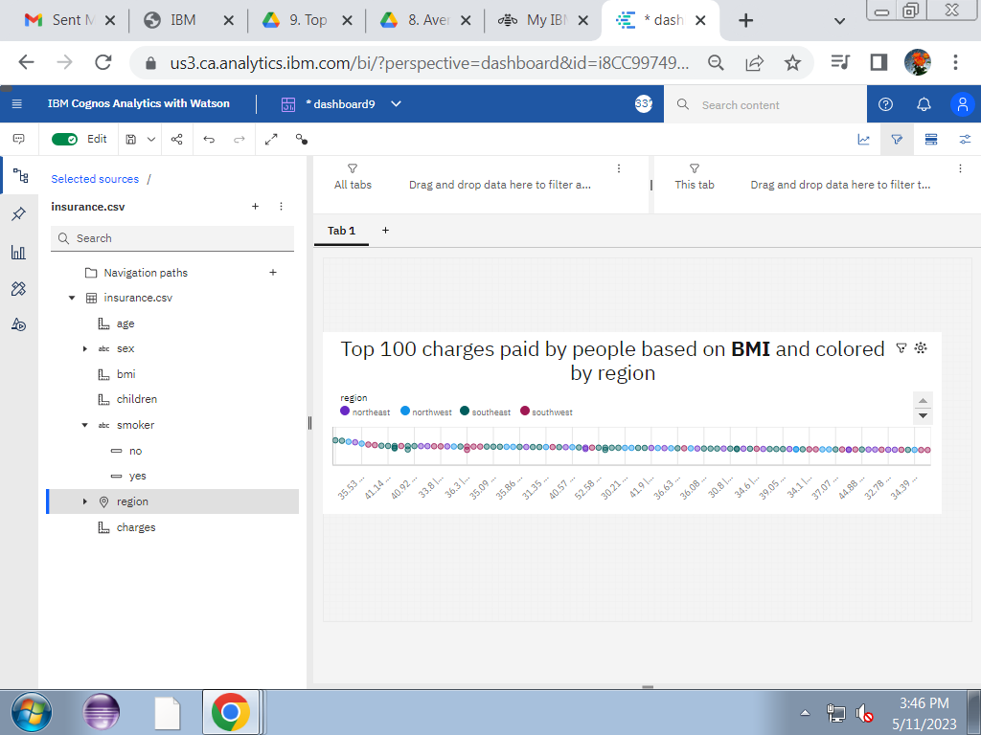

Link:[https://us3.ca.analytics.ibm.com/bi/?perspective=dashboard&pathRef=.my\_folders%2Fdashboard9&action=view&mode=dashboard&subView=model000001880a40253a\_00000002](https://us3.ca.analytics.ibm.com/bi/?perspective=dashboard&pathRef=.my_folders%2Fdashboard9&action=view&mode=dashboard&subView=model000001880a40253a_00000002" \t "_blank)

10. Number of Children to the people by region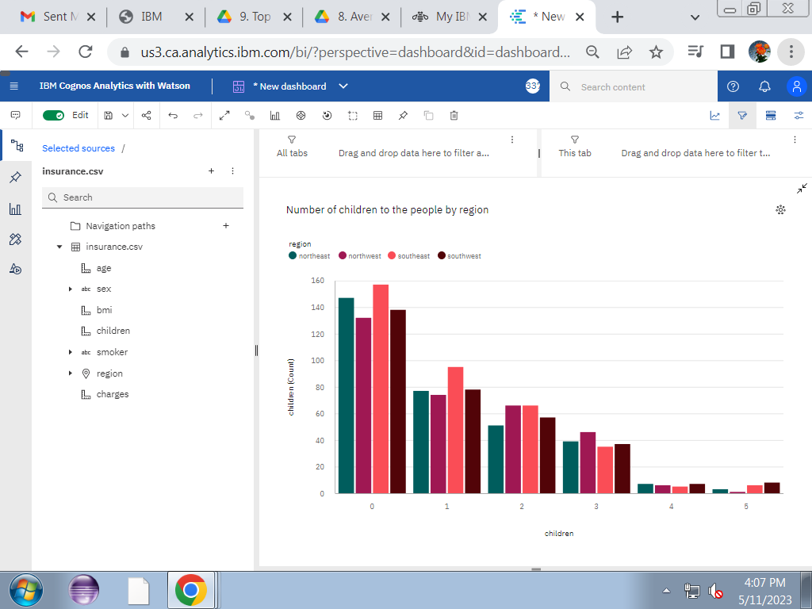

Link:[https://us3.ca.analytics.ibm.com/bi/?perspective=dashboard&pathRef=.my\_folders%2FNdashboard10&action=view&mode=dashboard&subView=model000001880a5503d7\_00000000](https://us3.ca.analytics.ibm.com/bi/?perspective=dashboard&pathRef=.my_folders%2FNdashboard10&action=view&mode=dashboard&subView=model000001880a5503d7_00000000" \t "_blank)

11. Charges paid by the people by region

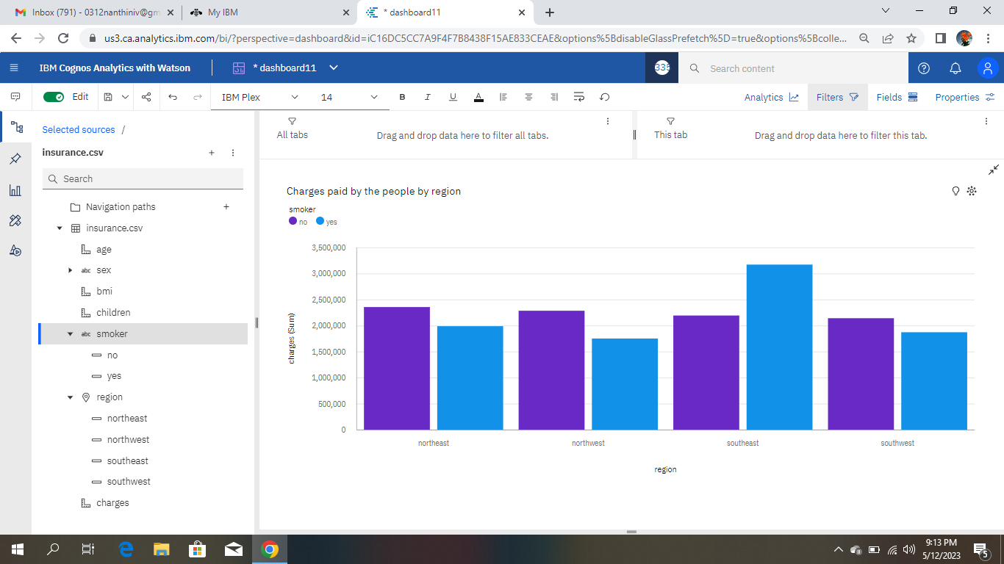

Link:[https://us3.ca.analytics.ibm.com/bi/?perspective=dashboard&pathRef=.my\_folders%2Fdashboard11&action=view&mode=dashboard&subView=model000001881452b641\_00000000](https://us3.ca.analytics.ibm.com/bi/?perspective=dashboard&pathRef=.my_folders%2Fdashboard11&action=view&mode=dashboard&subView=model000001881452b641_00000000" \t "_blank)

12. Charges based on the number of children

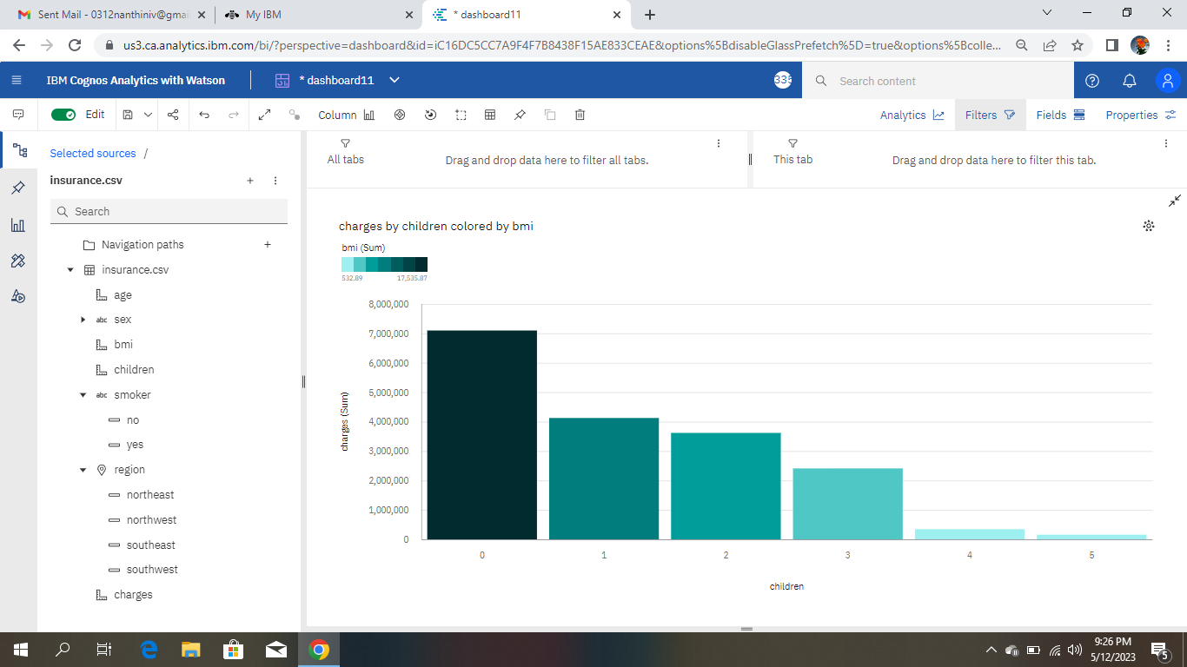

Link:<https://us3.ca.analytics.ibm.com/bi/?perspective=dashboard&pathRef=.my_folders%2Fdashboard11&action=view&mode=dashboard&subView=model0000018814655cf9_00000000>